Documents
- A Form 1099-R for a Traditional to Roth IRA Conversion should have Code 2 in box 7 if the participant is under age 59½ or Code 7 if the participant is at least age 59½ and the IRA/SEP/SIMPLE box checked.
- The amount converted is taxable income, but a Code 2 distribution is not subject to the additional 10% early distribution tax.
- Emphasize need to look at Box 7 at interview stage to determine if in scope!
- Caution: Code 2 can be used for other distributions, e.g. distribution to a Public Safety Officer after age 59 1/2
Entry into TSO
- Conversion from a Traditional to Roth IRA from 4012 Modified page D-38.
  - 1099-R box 7 Code 2 (participant is under age 59½) or Code 7 (the participant is at least age 59½). The amount converted is taxable income, but not subject to the additional 10% early distribution tax.
  - If box7 is Code 1, use Form 5329 and reason "Other" to eliminate the additional tax or the amount converted to a Roth.1.
  - Enter the amount converted in Box 1 and Box 2a on the 1099-R entry page.
  - Search for Form 8606 and enter the amount converted. If the traditional IRA had a basis, complete Part I of Form 8606
  - If the traditional IRA had a basis, also complete Part 1 of Form 8606. Taxpayer must have Form 8606 from a previous year return. See page D-33 of the NTTC Modified Pub 4012.

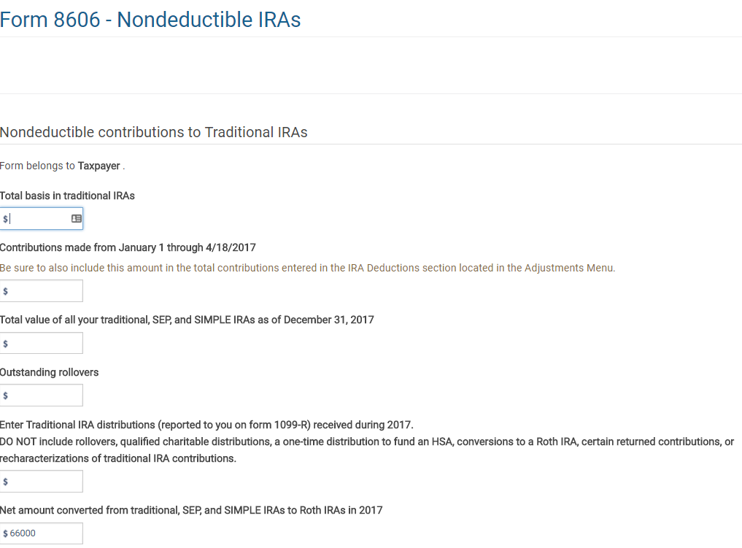
Cost basis if there is one
Enter the amount of the distribution from the traditional IRA that was converted to a Roth IRA

Print PDF of form 8606. Part II should look like this:
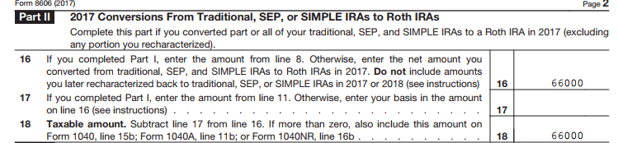
The amount on line 18 goes to the 1040 line 4b and is taxable.

